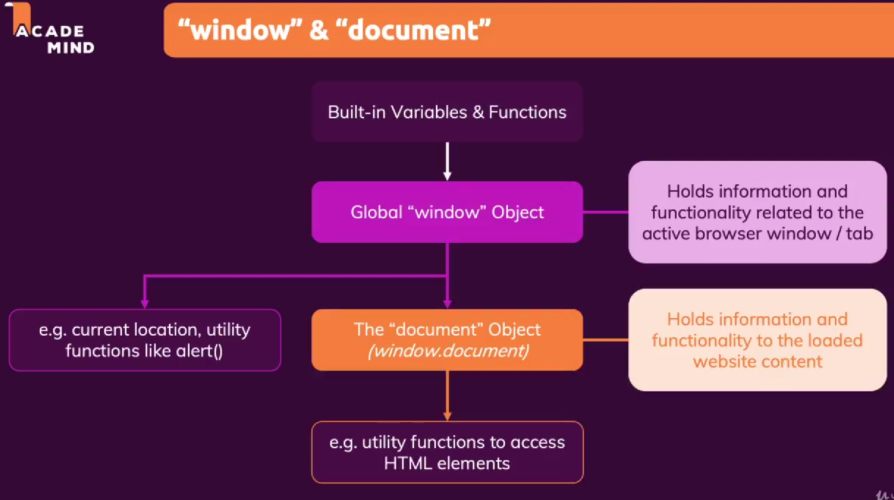

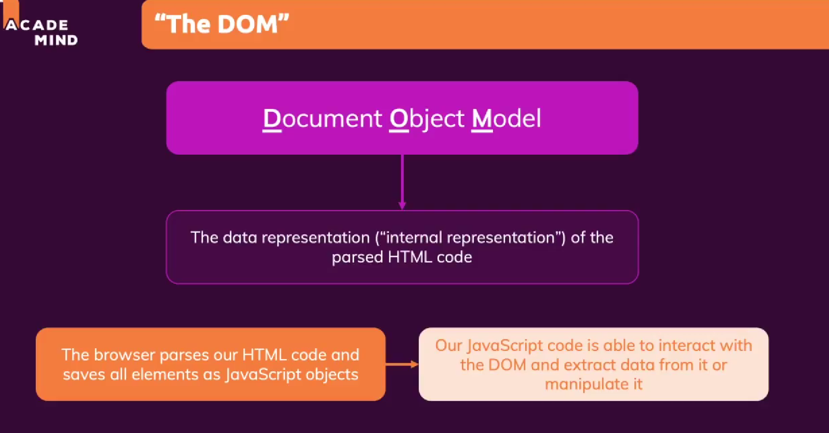

-console.dir is a different type of displaying emlements in console

-through that we can see what the user might have inputed throught html code

-We can assign values to links by targeting the specific part of the html

- To propery load the js code we add it at the end or add the attribute defer to tell the code that it should wait until all of the html code is executed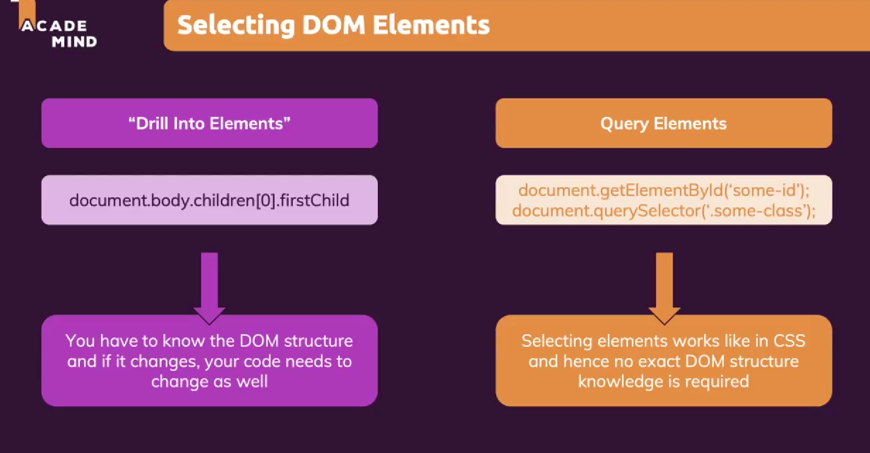

-We can use document.getElementById(‘id without the #’) which will look for the id we gave the element with css so we can tag it in js

-There is also document.querySelector(tag,id,class,combinators) so we can tag a element by anything

-To add a element there are 3 steps:

1.Create the new element

2.Get access to the parent element that should hold the new element

3.Insert the new element into the parent element content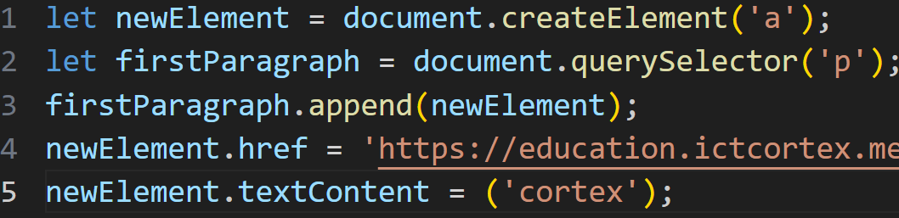

-To remove element we need to:

1.Select it

2.Remove it

-We can move elements by selecting the parent of the elements and then adding attributes like append,insertBefore()

-.innerHTML gives access to all html propertyes and elements in the element.It is used to add a mixture of html elements in the js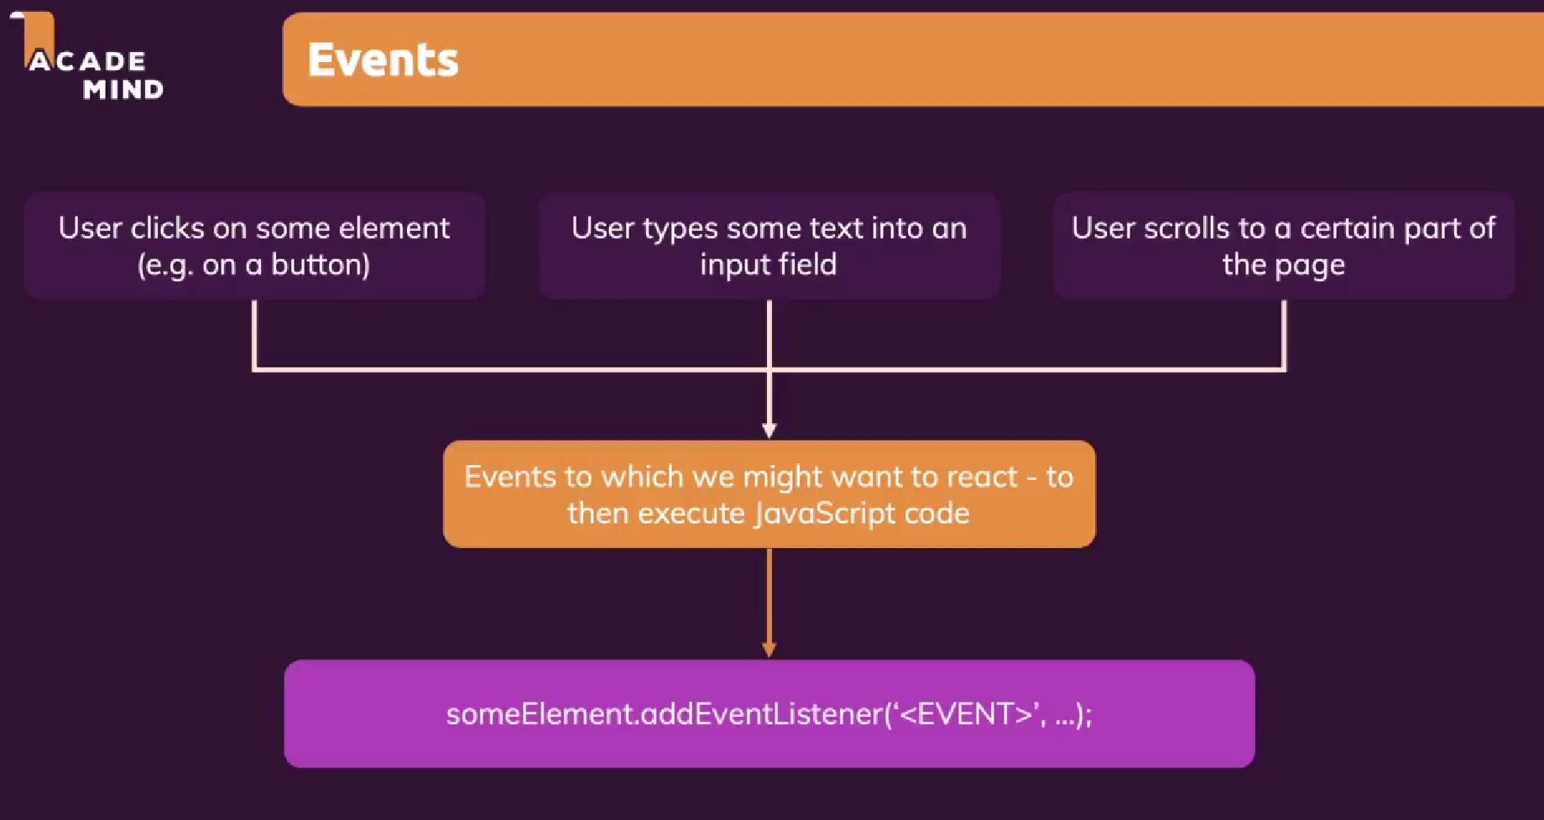

-.addEventListener adds a listener that listens to the user input inside the () the first property is the event that is happening that needs to be listened to and the second parameter is what should happen and it should point to a function

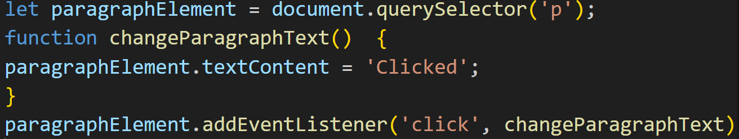

-input event listener listens to all events happening in the input field

-.value is used for the value of the input elements

-constants are the elements that never change and is written with const name = value

-In the constant we can change the some property but not the object itself

-.style can be used to apply css in js and the value shold be in the string

-with .className we can set classes in js it works only with the elements with no class

-.classList .add and .remove can also be used